Odorization
Odorization is a process of adding acrid substances (odorants – mercaptans) to heating oils in order to signal the leak of such gases. These products are our most successful ones.
- OSGC 03
- OSGC 04
- UMARS-MINI (universal metering and regulation station)
- DAMEOD-MINI (remote odorant reading)

OSGC 03
Odorizing units are an important safety element in the field of gas distribution. The OSGC-03 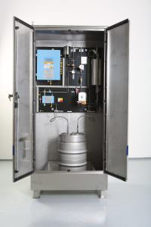A, B, C, D, I odorizing equipment provides precise and reliable metering of the odorant into the heating oil in the distribution equipment.
This equipment works on an injection basis. The impulses from the gas meter, or convertor, activate the pump via the equipment electronics. The membrane metering pump driven by a magnet is controlled by the UMARS control electronics. UMARS can also provide remote communication with a superior system, or PC..
The system is aerated through a filter with activated carbon. All components used in the OSGC odorizing stations are approved for Zone 2 with ATEX certificate by the Physical-Technical Testing Institute in Radvanice.

OSGC 03 A, B, C, D, I Technical Parameters
Voltage | 230V with 10% tolerance, 50/60 Hz
Output | 35W
Protection | IP65
Version | For ATEX Zone 2
Min. no. of strokes | 1 (min./manual setting)
Max. No. of Strokes | 10800/hod.
Operating Temperature | -30 +60 °C
Metered Medium | Odorants (mercaptans)
Pump Stroke Volume:
OSGC 03 A at 40 mg/Nm3= 36 500 Nm3, at 20 mg/Nm3 =18 250 Nm3 | 6.8-68 mg/stroke (at back-pressure of 30 bar)
OSGC 03 B at 40 mg/Nm3= 55 000, Nm3 at 20 mg/Nm3= 27 500 Nm3 | 10.2-102 mg/ stroke (at back-pressure of 30 bar)
OSGC 03 C at 40 mg/Nm3=105 000 Nm3, at 20 mg/Nm3=52 500 Nm3 | 19.9-195 mg/ stroke (at back-pressure of 30 bar)
OSGC 03 D at 40 mg/Nm3=205 000 Nm3, at 20 mg/Nm3=102 500Nm3 | 38-380 mg/ stroke (at back-pressure of 30 bar)
OSGC 03 I – according to the individual offer | According to the selected construction
Equipment Weight | 38 kg
Dimensions (H x W x D) (mm) | 950 x 900 x 300 (only type A,B,C,D)

OSGC 04
The functionality of an odorizing station lies in an effective connection of electromagnetic valves. The components are controlled by the UMARS-MINI electronics located directly on the installation panel. The operating liquid is metered by a high-pressure electromagnetic valve, which uses the gas pressure from the regulation station, or a pressure bottle. It is a simple, but highly effective odorizing system.
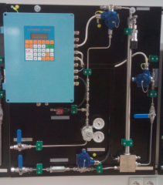

UMARS-MINI
is a universal metering and regulation equipment. The control PLC system is the central unit. The input signal is digital or analogue from a designated device. 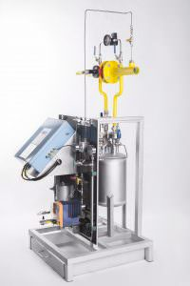UMARS-MINI contains 6 digital, user-programmable inputs, and 8 analogue inputs. Communication may be provided via Ethernet, DB-Net protocol, or via RS485, either by DB-Net protocol, or MODBUS. The optional input signals can be programmed in AMIT-DetStudio, which can be downloaded from the Internet for free.
The equipment is approved by the PHYSICAL-TECHNICAL TESTING INSTITUTE, a state enterprise in Ostrava-Radvanice, and it can be used in Zone 2 in an environment with explosion hazard of the gaseous atmosphere. The equipment meets the requirements of standards CSN EN 60079-0, ed.4, CSN EN 60079-11, ed.2, and CSN EN 60079-15, ed.3.
The equipment may be installed and commissioned only by a qualified employee who has to be knowledgeable about the methods of protection against explosion, and regulations and provisions for devices in areas with explosion hazard.

UMARS-MINI Technical Data
Dimensions [w/h/d] | Weight [approx.] | Materiál | Protection
310x400x110 mm | 9,5 kg | aluminium | IP54

DAMEOD-MINI
DAMEOD-MINI is a device that monitors odorant concentration. DAMEOD-MINI may be installed directly in ZONE 2 with explosion hazard, or outside in the “stainless” version.
The advantages of DAMEOD include that operators do not have to check odorant concentration in the end branches with manual devices, but they can comfortably monitor these values from the control room. It allows them to remotely set the required values of mg/Nm3 in odorizing stations, which ensures significant savings. Also, data can be printed in the form of a protocol or in a chart to document retrospectively concentrations on particular days and time.
The device can be fed via UPS (located outside ZONE 2).
Readings are taken by sensors that are standardly fitted in the portable metering devices used for measuring odorant concentrations.
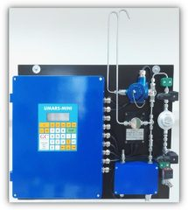

DAMEOD-MINI Technical Parameters
Input Voltage | 230VAC
Max. Current Taken | 0,9Ah
TBM, THT, Spotleak , Spotleak Odorant Sensor | 0-50mg/Nm3
Communication | MODBUS (RS485), DB-Net (RS232, ethernet)
Dimensions | H 600*W 600*D 300
In case of a “full” utilization of the control automat, it is possible to add three* analogue sensors, door contacts or other binary signals (such as capacity sensors of the position of safety quick-closing valves etc.).

Photogallery
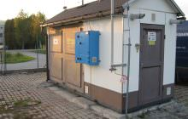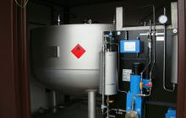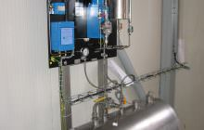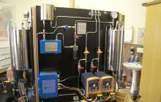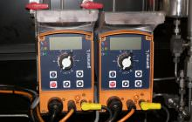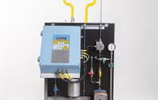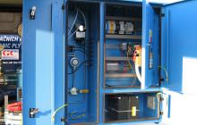

Files
- DS_OSGC

- DS UMARS MINI

- DS DAMEOD MINI

